CS 4407-01 Data Mining and Machine Learning

Instructor: Professor Shabia Shabir

Name: Anonymos

Programming Assignment Unit 6

**Part 1: Write the pattern file**

**a. Input file**

The 7-segment display represents numbers and characters by lighting (1) or not lighting (0) each segment. The input patterns are shown below:

1 1 1 1 1 1 0

0 1 1 0 0 0 0

1 1 0 1 1 0 1

1 1 1 1 0 0 1

0 1 1 0 0 1 1

1 0 1 1 0 1 1

1 0 1 1 1 1 1

1 1 1 0 0 0 0

1 1 1 1 1 1 1

1 1 1 1 0 1 1

1 1 1 0 1 1 1

0 0 1 1 1 1 1

1 0 0 1 1 1 0

0 1 1 1 1 0 1

1 0 0 1 1 1 1

1 0 0 0 1 1 1

**b. Output file**

The output is converted into a binary format based on ASCII codes. The output values are as follows:

0 1 1 0 0 0 0

0 1 1 0 0 0 1

0 1 1 0 0 1 0

0 1 1 0 0 1 1

0 1 1 0 1 0 0

0 1 1 0 1 0 1

0 1 1 0 1 1 0

0 1 1 0 1 1 1

0 1 1 1 0 0 0

0 1 1 1 0 0 1

1 0 0 0 0 0 1

1 0 0 0 0 1 0

1 0 0 0 0 1 1

1 0 0 0 1 0 0

1 0 0 0 1 0 1

1 0 0 0 1 1 0

1 0 0 1 0 0 0

**c. Pattern file**

Based on the above information, a text file for training was created. The content is as follows:

Number of patterns = 17

Number of inputs = 7

Number of outputs = 7

[patterns]

1 1 1 1 1 1 0 0 1 1 0 0 0 0

0 1 1 0 0 0 0 0 1 1 0 0 0 1

1 1 0 1 1 0 1 0 1 1 0 0 1 0

1 1 1 1 0 0 1 0 1 1 0 0 1 1

0 1 1 0 0 1 1 0 1 1 0 1 0 0

1 0 1 1 0 1 1 0 1 1 0 1 0 1

1 0 1 1 1 1 1 0 1 1 0 1 1 0

1 1 1 0 0 0 0 0 1 1 0 1 1 1

1 1 1 1 1 1 1 0 1 1 1 0 0 0

1 1 1 1 0 1 1 0 1 1 1 0 0 1

1 1 1 0 1 1 1 1 0 0 0 0 0 1

0 0 1 1 1 1 1 1 0 0 0 0 1 0

1 0 0 1 1 1 0 1 0 0 0 0 1 1

0 1 1 1 1 0 1 1 0 0 0 1 0 0

1 0 0 1 1 1 1 1 0 0 0 1 0 1

1 0 0 0 1 1 1 1 0 0 0 1 1 0

1 0 0 1 0 0 0 1 0 0 1 0 0 0

**Part 2: Analysis results**

The created `pat` file was used for analysis. The results of parameter adjustments for optimization are explained below.

**Network Configuration**

The input and output units are fixed at 7. After analyzing the training results, a Layer 1 unit size of **10** was deemed optimal. The network configuration is shown below.

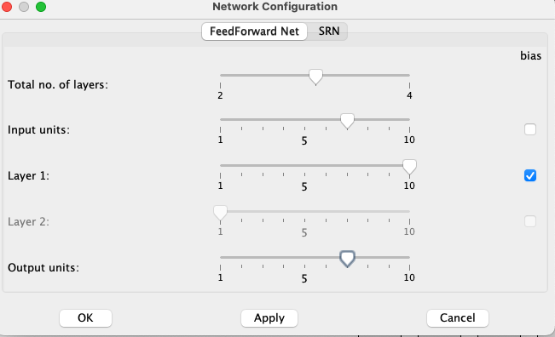

Figure 1: Network Configuration

**Control Panel Settings**

The main parameters adjusted in the control panel were:

1. Learning rate: Changed from the default 0.3 to 0.2.
2. Momentum: The default value of 0.8 was retained.

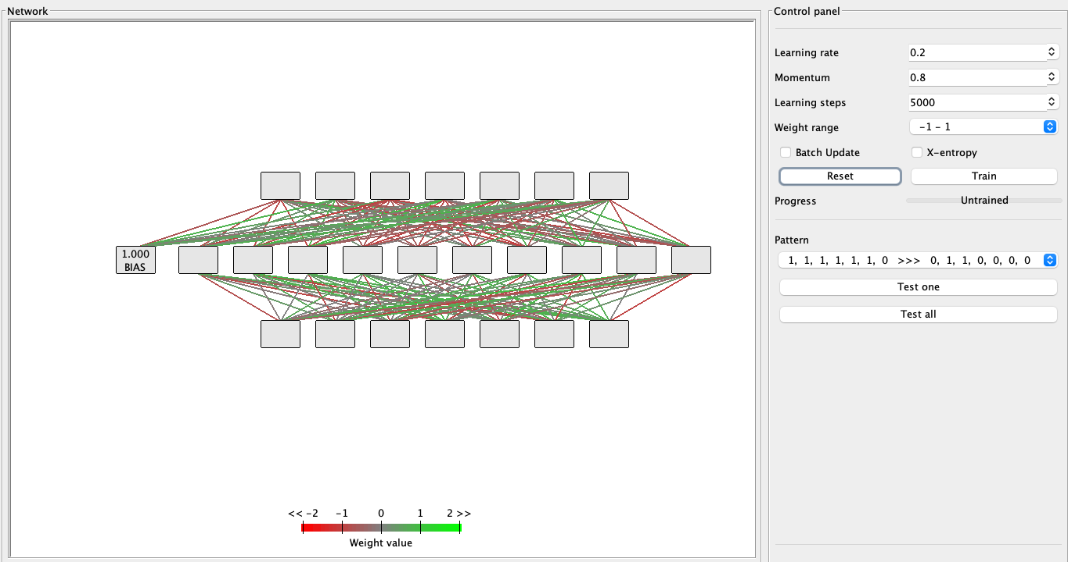

Figure 2: Parameter Settings

Below is an example of an Error Progress graph for an inappropriate configuration.

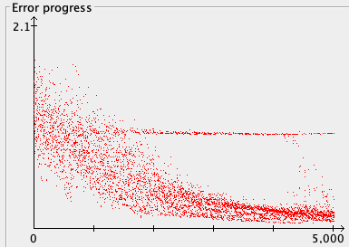

Figure 3: Bad Pattern

**Results**

At 5000 iterations, the error rate was 0.127, and at 25000 iterations, it ultimately reached 0.04364.

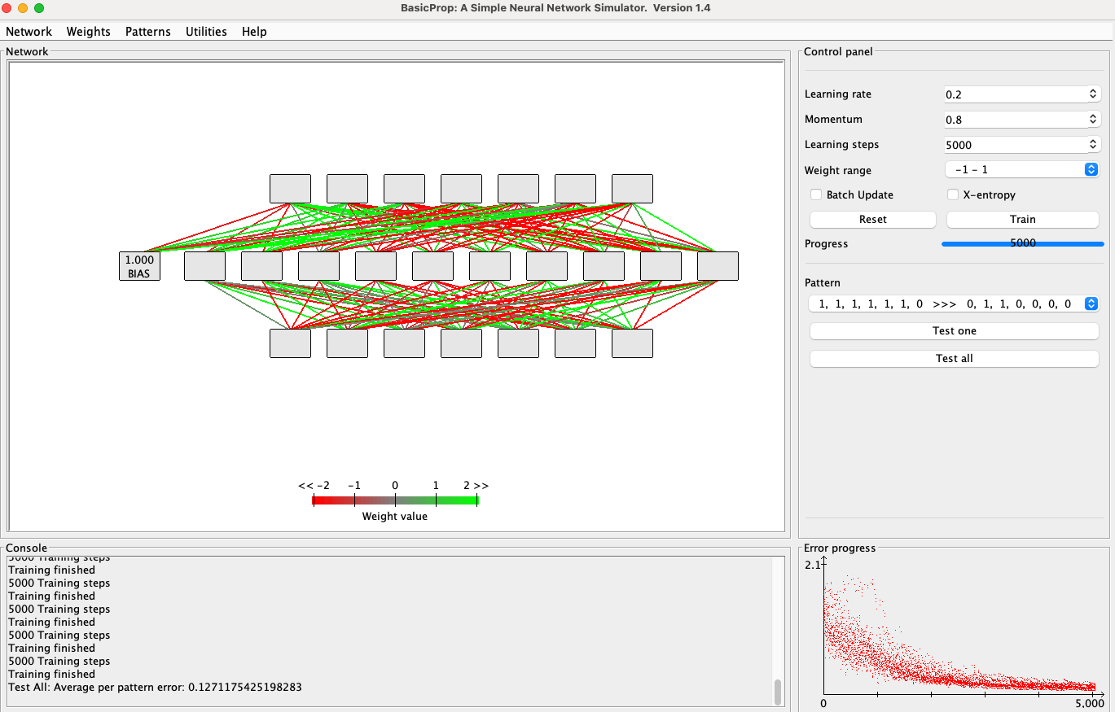

Figure 4: Error Progress after 5000 iterations

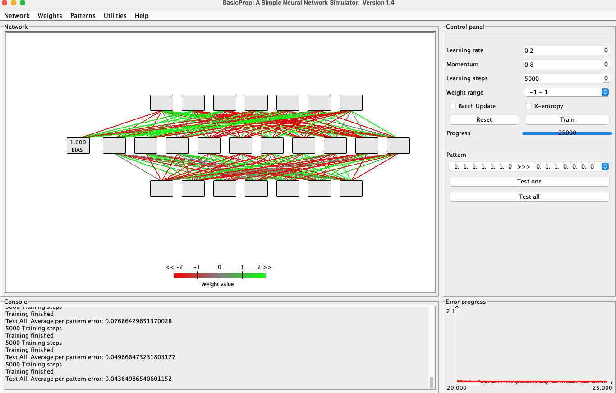

Figure 5: Error Progress after 25000 iterations

**Average Error Rate and Results**

The average error rates for each pattern are as follows:

Pattern: " 1, 1, 1, 1, 1, 1, 0 >>> 0, 1, 1, 0, 0, 0, 0 "

Result: " 0.02, 0.98, 0.98, 0.04, 0, 0.03, 0.02 "

Pattern: " 0, 1, 1, 0, 0, 0, 0 >>> 0, 1, 1, 0, 0, 0, 1 "

Result: " 0.01, 0.99, 0.99, 0.01, 0.02, 0.01, 0.97 "

Pattern: " 1, 1, 0, 1, 1, 0, 1 >>> 0, 1, 1, 0, 0, 1, 0 "

Result: " 0.01, 0.99, 0.99, 0.02, 0.01, 0.99, 0.01 "

Pattern: " 1, 1, 1, 1, 0, 0, 1 >>> 0, 1, 1, 0, 0, 1, 1 "

Result: " 0, 1, 1, 0.02, 0.03, 0.97, 0.98 "

Pattern: " 0, 1, 1, 0, 0, 1, 1 >>> 0, 1, 1, 0, 1, 0, 0 "

Result: " 0.02, 0.98, 0.98, 0.01, 0.97, 0, 0.03 "

Pattern: " 1, 0, 1, 1, 0, 1, 1 >>> 0, 1, 1, 0, 1, 0, 1 "

Result: " 0.01, 1, 1, 0.02, 0.99, 0.01, 0.98 "

Pattern: " 1, 0, 1, 1, 1, 1, 1 >>> 0, 1, 1, 0, 1, 1, 0 "

Result: " 0.02, 0.98, 0.98, 0, 0.99, 0.99, 0 "

Pattern: " 1, 1, 1, 0, 0, 0, 0 >>> 0, 1, 1, 0, 1, 1, 1 "

Result: " 0.01, 0.99, 0.99, 0, 0.96, 0.99, 1 "

Pattern: " 1, 1, 1, 1, 1, 1, 1 >>> 0, 1, 1, 1, 0, 0, 0 "

Result: " 0, 1, 1, 0.96, 0, 0, 0.03 "

Pattern: " 1, 1, 1, 1, 0, 1, 1 >>> 0, 1, 1, 1, 0, 0, 1 "

Result: " 0, 1, 1, 0.97, 0, 0.01, 0.97 "

Pattern: " 1, 1, 1, 0, 1, 1, 1 >>> 1, 0, 0, 0, 0, 0, 1 "

Result: " 0.98, 0.02, 0.02, 0.01, 0.03, 0.02, 0.97 "

Pattern: " 0, 0, 1, 1, 1, 1, 1 >>> 1, 0, 0, 0, 0, 1, 0 "

Result: " 0.99, 0.01, 0.01, 0, 0.02, 0.97, 0 "

Pattern: " 1, 0, 0, 1, 1, 1, 0 >>> 1, 0, 0, 0, 0, 1, 1 "

Result: " 1, 0, 0, 0, 0, 0.98, 0.98 "

Pattern: " 0, 1, 1, 1, 1, 0, 1 >>> 1, 0, 0, 0, 1, 0, 0 "

Result: " 0.98, 0.02, 0.02, 0, 0.98, 0.02, 0 "

Pattern: " 1, 0, 0, 0, 1, 1, 1 >>> 1, 0, 0, 0, 1, 1, 0 "

Result: " 1, 0, 0, 0, 0.99, 0.99, 0.03 "

Pattern: " 1, 0, 0, 0, 1, 1, 1 >>> 1, 0, 0, 0, 1, 1, 0 "

Result: " 1, 0, 0, 0, 0.99, 0.99, 0.03 "

Pattern: " 1, 0, 0, 1, 0, 0, 0 >>> 1, 0, 0, 1, 0, 0, 0 "

Result: " 0.99, 0.01, 0.01, 0.98, 0, 0.01, 0.03 "

**Optimization Example**

By setting the Learning rate to 0.4 and Momentum to 0.9, an error rate of 0.026299 was achieved.

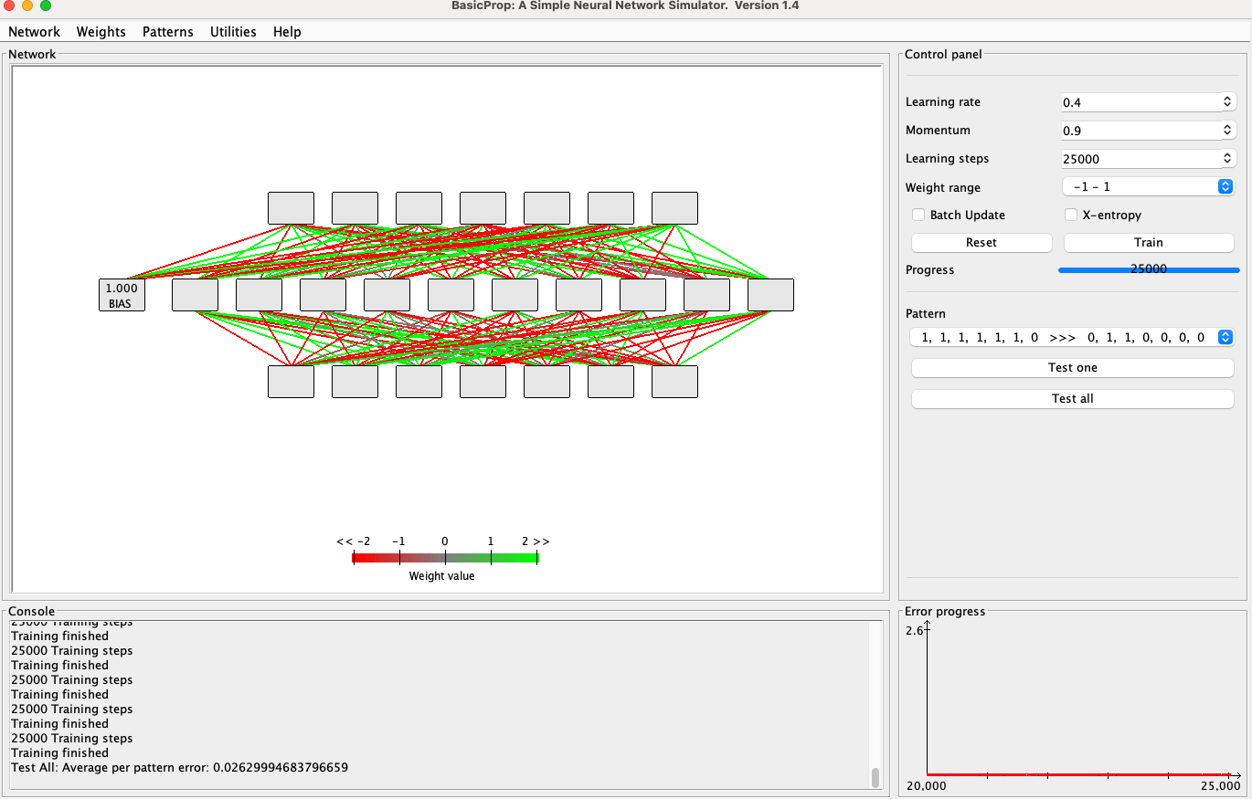

Figure 6: Optimized Parameters

Word Count: 1,211

References

1. James, G., Witten, D., Hastie, T., & Tibshirani, R. (2013). *An Introduction to Statistical Learning with Applications in R*. New York, NY: Springer.